Maximilien Malderle

ID: 26562906

SOEN 422

LAB 2

Introduction:

The purpose of this lab is to use the Arduino nano board to set up three different methods of communication. The first is called UART and utilizes a USB connection to communicate information from the nano to a computer or vice versa. The second method of communication is called SPI, which utilizes 4 connection points between two nano chips. SPI is a form of duplex communication i.e. it can send and receive data at the same time using a serial protocol. The last method is called I2C which utilizes a bus communication pattern. Both SPI and I2C require the creation of a master and one or multiple slaves. The first question of the lab requires a UART connection between the computer and the nano, information such as a name, will be sent to the board, where a greeting, which incorporates the received name, shall be created and sent back to the computer. The second question requires a UART connection between the computer and a nano, with an additional connection between the two Nanos. The master nano will be connected to the computer and to the slave nano, which will be connected to an IR sensor. Data from the sensor will be communicated to the master nano through SPI and the master will communicate this information to the computer through a UART connection. The third question requires the same set-up and goal as the second, but the SPI connection is replaced by a I2C connection.

Physical Resources:

For all of the questions the Arduino nano is used, for parts 2 and 3 two are used. In questions 2 and 3 there is also a capacitor and IR sensor which are required.

Question 1:

Power to the Arduino is provided by the USB port, which is connected to the computer. A ground and power is connected to the bread board. On the picture two wires are used to connect the bus with the nano’s power and ground to the other side to provide power to a second nano, which will not be used in this case. There is also an LED array with a ground, which has no use other than to test the output of ports in questions 2 and 3.

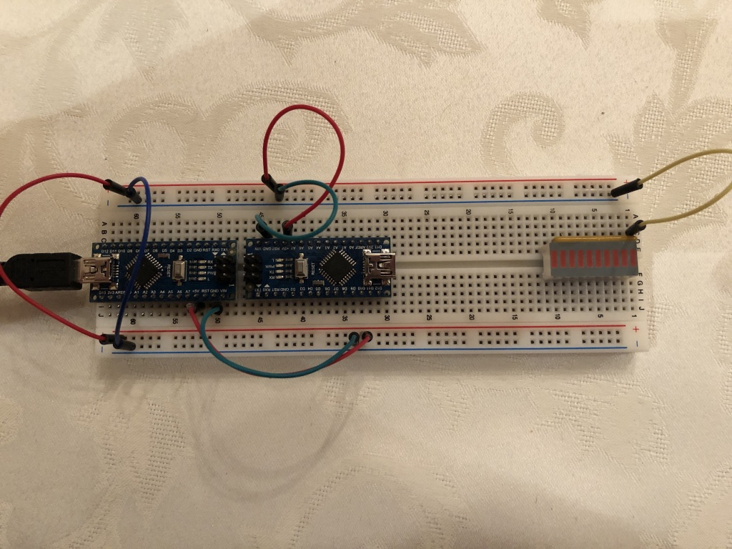

Question 2:

The setup on this board is exactly the same as for question one, except for the interconnections between the boards and the IR sensor on the slave. The master has a 4 connections to the slave, each port is mapped to the same port on the other board. The master sets pins D10{PB2, SS}, D11{PB3, MOSI} and D13{PB5, SCK} as outputs and pin D12{PB4,MISO} as an input. The slave sets the pins as the opposite as the master. MOSI stands for master out slave in, MISO stands for master in slave out, SCK is for the clock used for communication and SS stands for slave select. The slave also has an IR sensor connected to pin A0{PC0} as an input. Between the rail connection and the nano connection there is a capacitor to make the signal smoother for the IR sensor.

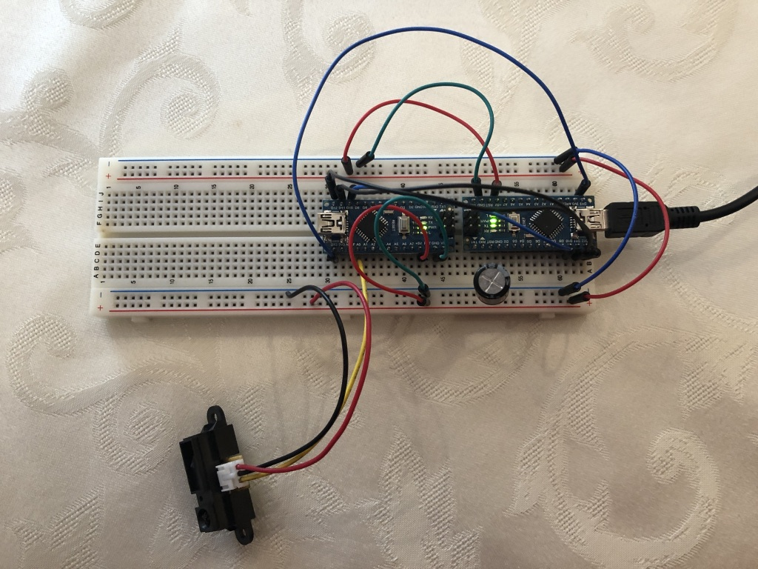



IR Sensor is Connected to Slave Pin A0 and is connected to the powerline with a capacitor between it and the source.

Question 3:

The IR sensor is setup is the same as in Question 2. Here there are two 4.7 ohm resistors inserted into the master’s A5{PC5,SCL} and A4{PC4, SDA} pins, which are connected to the positive rail, these resistors act as pull-up resistors for I2C communication. There are also two connections from these pins to the corresponding pins on the slave.

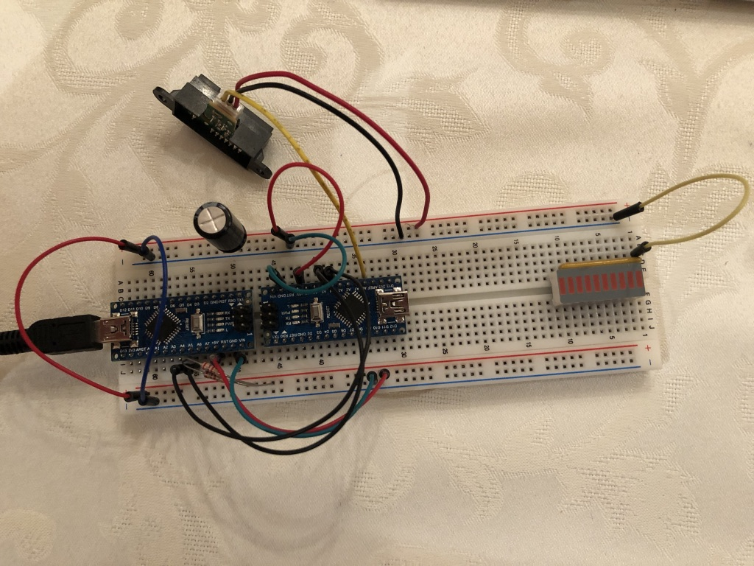



IR Sensor is Connected to Slave Pin A0 and is connected to the powerline with a capacitor between it and the source.

Software Resources:

To complete this lab, only pure C code was utilized, it was compiled through the Arduino IDE, yet it is now possible to compile and load the software through the terminal. The programming was done in “Bare Metal” requiring C libraries, to allow for bit wise manipulation of the hardware registers. The functions are declared before the main in the program file, with a main which runs the majority of the functions in a indefinite loop. The CPU frequency and the BAUD rate are defined as global variables at the beginning of every program.

Program Snippets:

In this section snippets of code will be presented to show how certain necessary parts to the problems are solved.

**Problem 1 (UART Communication):**

**Definitions:**

These definitions are used to set key information relating to the hardware, so that the communication between the nano and the pc are in sync.



**Initiation Protocol:**

This function is created to set the BAUD rate in the appropriate register, while activating the sending and receiving capabilities of the nano.



**Receive Character Function:**

Used to communicate a character from the serial Monitor to the nano.



**Send Character Function:**

Used to communicate a character to the Serial Monitor from the nano.



**Send Message Function:**

Used to send a string of characters to the Serial Monitor from the nano.



**Main Function:**

**Variable Declarations:**



**Main Operations:**

The logic here is that a character is read from the serial monitor and stored into a char array named msg, after this the index is incremented. This happens until the serial monitor reads a line break character, then the accrued characters in the msg array and the saved greetings message are written to the serial monitor. Afterwards the msg array is cleared and the index is set back to 0.



**Problem 2 (SPI Communication):**

**Master:**

**Global Variables:**



**UART Communication Initiation and Send/Receive functions from problem 1**

**Initialization of Master Nano:**

This is used to set the master pins and the registers to a master configuration.



**Transceiver Function:**

Accepts 8-bit data to send and returns 8-bit data, which was received.



**IR_Data Array Reset Function:**

The point here is to set the character array that holds the IR data back to NULL, so that no value is reused if not overwritten in the next cycle.



**IR Receiver function**

**Variables:**



**Work Portion:**



The logic here is that the Transceiver function receives bytes of data from the slave and stores it in a variable, if the value is a number in the range of 0-9 it will be stored in the char array, this is done three times (Corresponding to the format of the IR data from the sensor).

**Serial Monitor Message presentation:**



The logic here, is that there are 3 pieces of data that are received from the IR sensor. Once the index reaches 3 the accumulated data from the sensor is presented with an additional message to add context. Afterwards the array containing the IR data is reset alongside the index.

**Main Program:**

**Initialization and Variables:**



**Working Portion:**



The logic here is that a message is displayed to the user through the Serial Monitor asking for the user to input a ‘1’ if they wish to have one value from the IR Sensor to be presented. If one is read the IR_ON function is run once and the message is displayed again, continuing the process.

**Slave:**

**Global Variables:**



**Baud rate, Send/Receive, IR_Sensor Initialization:**

The BAUD rate and the Send/Receive activation are for UART communication, which is not utilized by the slave. The initialization of the IR sensor is the same as in lab 1b.



**Initialization of Slave Nano:**



**Transceiver Function:**

Same as the Master function.



**IR Sensor Function:**

IR setup is very similar to that in Lab 1b. The only difference is that an integer cannot be sent out in an 8-bit register. Therefor the integer is broken into 3 portions the 100, 10 and 1 and is converted into a char which is stored in a 3-index array.



**Main Program:**

**Initialization of Variables:**



**Working Section:**

The logic here is that the IR_Sensor function accepts the 3-char array and fills it with IR data. Afterwards the program cycles through the array and sends the char one by one from the slave to the master.



**Problem 3 (I2C Communication):**

**MASTER:**

Does not work properly, will present current configuration.

**Definitions:**



**Global Variables:**



Stores the Slaves address plus read bit as a 8-bit variable.

**Initialization protocol:**



Baud and Send/Receive are for UART communication. The pre-scaler is initialized to 1 by setting the TWSR register. The frequency of 400 hz corresponds to the hex variable 0C which represents 12, which is stored in the TBWR register. TWI communication is enabled by setting the TWEN bit in the TWCR register.

**TWI Status Function:**



TWSR register is where statuses are written when certain conditions have been fulfilled. The (TWSR & 0xF8) makes sure to mask the three least significant bits, which are used for another purpose.

**Start Condition:**

This is used to signal the beginning of a communication.



**Load Address:**

This is used to load the Slave address into the data register while setting the proper bits.



**Load Data:**

This is used to load the data into the data register while setting the Interrupt flag and enabling TWI communication, then waiting for the TWINT flag to be set to 0, indicating a that the transfer is complete.



**Receive Data ACK:**

This is used to confirm that the data was received and returns the contents of the data register. The TWCR register has the TWINT, TWEN and TWEA bits are set to one, to enable TWI communication, set the Interrupt Flag and to acknowledge the ACK signal.



**Receive Data Non-ACK:**

This is used to receive a message from the slave in an NACK condition, signaling the end of a transmission.



**Stop Conditions:**

This is used to convey the end of a communication cycle, by changing the TWCR register bits and by changing the hardware electrical flow.



**IR Function:**

This function is used to create a communication link between the master and the slave, to then send the master Infra-Red data.

**Variables:**



**Working Portion:**



The logic here is that the START is sent to the slave, to then load the Slave Address and Read bit to the slave, which then returns an ACK which sets the TWSR result to 0x40. Afterwards the received byte is stored in a variable, tested for correctness and then stored in a char array. After the last byte is received, the NACK is read and the STOP condition is enacted. Afterwards the Information is presented to the user through UART communication.

**Main Program:**

**Variables and Initialization:**



**Working portion**

The logic here is exactly the same as for the SPI main program.



**SLAVE:**

Everything is the same other than the Initialization of the salve, the loading of data and the Main program.

**Global Variables:**

This sets the Slave address to 1 with an additional 0 padded on the right.



**Initialization:**

Here the pre-scaler is set to 1 by storing 0x00 in the TWSR Register. The frequency is set to 400 hz by loading 0x0C in the TWBR register. The slave address is saved in the TWAR address register. The enable and ACK bits are set to 1 in the TWCR register.



**Load Data:**

The function is the same as in the Master other than the TWEA bit is set to 1 in the TWCR register.



**Main Program:**

**Variables and Initiation:**



**Working Portion:**

The logic here is that the ACK bit is set to one, making sure that when the address and read bit are received that the Slave can signal an ACK to the master. Thereafter the IR data is stored in a char array. After the data is sent one byte at a time the ACK is set to 0 to make sure the master receives the NACK condition. The continue is useless, but the program does not work without it for some reason.



Reference Code Common:



Avr/io.h is used so that the C language can set all the register bits.

Stdint.h allows for the bool data type.

Util/delay.h is included to give the user the ablity to call _*delay_*ms() functions, creating a waiting condition in the program.

String.h is used to utilize the string variable. Most of the time char* var is used in the place of a string variable.

Conclusion/Discussion:

This lab is focused on communication, but also builds on the previous lab. UART communication is used to replace the Serial library that was used for pc nano USB communication. The second goal of this lab is to create communication channels between two nanos, through either SPI or I2C protocols. SPI utilizes 4 pin connections to establish the channel between the slave and master nano. I2C utilizes a bus communication channel by connecting the master and slave together through SCL and SDA pins. Communication speed in I2C exceed those available through SPI. All this can be done without any software packages, everything is done through bare metal programming.